

UNIVERSITY OF RIBEIRÃO PRETO
CENTER OF EXACT SCIENCES, NATURAL SCIENCES AND TECHNOLOGIES
GRADUATE PROGRAM IN ENVIRONMENTAL TECHNOLOGY

NAME (FONT SIZE 12)

TITLE (FONT SIZE 12)

Ribeirão Preto (Font Size 12)
Year (Font Size 12)
NAME (FONT SIZE 12)

TITLE (FONT SIZE 12)

Dissertation presented to the University of Ribeirão Preto - UNAERP, as an evaluation requirement for obtaining a Master's degree from the Postgraduate Program in Environmental Technology.

Advisor: Prof. Dr.
Co-advisor: Prof. Dr.

Ribeirão Preto (Font Size 12)
Year (Font Size 12)

The catalog sheet is prepared online by the student himself.

- University of Ribeirão Preto –

Sobrenome, Nome,
Título do Trabalho/ Nome do Aluno – Ribeirão Preto, ANO.
XX f.: il. Color.

Orientador: Prof. Dr.

Tese (doutorado) - Universidade de Ribeirão Preto, UNAERP, Tecnologia Ambiental. Ribeirão Preto, ANO.

1. XX. 2. XX. 3. XX.
CDD XX

NAME (FONT SIZE 12)

TITLE (FONT SIZE 12)

Dissertation presented to the University of Ribeirão Preto - UNAERP, as an evaluation requirement for obtaining a Master's degree from the Postgraduate Program in Environmental Technology.

Concentration Area: Environmental Technology

Result: ___________

Approved: ___/___/___

______________________________________________
Prof. Dr.
University of Ribeirão Preto - UNAERP
Advisor

______________________________________________
Prof. Dr.
University ....

______________________________________________
Prof. Dr.

Dedicatory
Margin 8 cm to the right; Times New Roman size 12; Arial size 10, Spacing 1.5 between lines.
ACKNOWLEDGMENTS (FONT SIZE 12)

This text should be the author's own choice. When financial support for the research is provided, it is suggested that the funding agency be credited.
Formatting: Justified alignment; Arial or Times New Roman font; 1.5 line spacing; size 12

Epigraph - Times New Roman or Arial font; size: 10 (Arial) 12 (Times New Roman); 1.5 cm line spacing; Text highlighted in italics;
Reference of the author of the text in brackets and aligned to the right/left.
There is no formatting rule regarding alignment. It can be right- or left-aligned; both are acceptable. However, in most cases, correct alignment is used.
ABSTRACT (FONT SIZE 12)

The abstract is written in a single paragraph. Arial or Times New Roman font; size 12; justified alignment; single line spacing; written in the third person singular; active voice. According to NBR 14724, the abstract consists of a concise presentation of the relevant points of a text; it is made up of a sequence of concise and objective sentences and not a simple enumeration of topics, not exceeding 500 words, followed immediately below by the words that represent the content of the work, i.e., keywords and/or descriptors, according to [NBR 6028]. The keywords are separated from each other by a semicolon and end with a period. Use three to five keywords.

Keywords: XX; XX; XX.

RESUMO (FONTE TAMANHO 12)

A formatação do resumo segue a mesma do abstract.

Palavras-chave: XX; XX; XX.

RESUMO ESTENDIDO (FONTE TAMANHO 12)

O trabalho deverá incluir um resumo estendido, com 4 a 6 páginas, redigido em língua portuguesa. Esse resumo deve abranger as seguintes seções: Introdução, Objetivos, Metodologia, Resultados e Discussão, Conclusão e Palavras-chave.

Introdução
Aqui deve ser descrito a introdução. O texto deve ser justificado, fonte Times New Roman ou Arial, tamanho 12, espaçamento 1,5 entre linhas.

Metodologia
Aqui deve ser descrito a metodologia. O texto deve ser justificado, fonte Times New Roman ou Arial, tamanho 12, espaçamento 1,5 entre linhas.

Resultados e Discussão
Aqui deve ser descrito os resultados e discussão. O texto deve ser justificado, fonte Times New Roman ou Arial, tamanho 12, espaçamento 1,5 entre linhas.

Conclusão
Aqui deve ser descrito a conclusão. O texto deve ser justificado, fonte Times New Roman ou Arial, tamanho 12, espaçamento 1,5 entre linhas.

Palavras-chave
LIST OF FIGURES (FONT SIZE 12)

Figure 1 - Lungs 17

LIST OF TABLES (FONT SIZE 12)

Table 1 - Distribution of the number and percentage of live births according to the mother's level of education 18
Table 2 - Norms used to write a scientific article 19

LIST OF ACRONYMS (FONT SIZE 12 - OPTIONAL)

The List of Acronyms is optional and desirable when there are many acronyms in the work.

ABL Academia Brasileira de Letras;
CNPq Conselho Nacional de Pesquisa;
CPQ Controle de Qualidade de Processos;
IPT Instituto de Pesquisas Nucleares;
ITC Instituto de Levantamento Aeroespacial e Ciências de Terras;
ONU Organização das Nações Unidas;
SI Sistema Internacional de Unidades.

LIST OF SYMBOLS (FONT SIZE 12 - OPTIONAL)

The List of Symbols is optional and desirable when the work has many symbols.

CONTENTS (FONT SIZE 12)

1 INTRODUCTION (FONT SIZE 12) 16
1.1 OBJECTIVES (FONT SIZE 12) 17
1.1.1 General Objective (Font Size 12) 17
1.1.2 Specific Objectives (Font Size 12) 17
2 LITERATURE REVIEW (FONT SIZE 12 FOR ALL TITLES) 18
2.1 TITLE 2 (TITLE SHOULD BE WRITTEN IN CAPITAL LETTERS) 18
2.2 METALLIC PARTICLES 18
2.1.1 Title 3 (First Letter of Each Word in Capitals) 18
2.1.2 Gold Nanoparticles 18
2.1.1.1 Title 4 (Only the first letter of the first word capitalized) 18
2.1.1.2 Gold nanoparticle applications 18
3 MATERIAL AND METHODS (FONT SIZE 12) 21
3.1 TITLE 2 (TITLE SHOULD BE WRITTEN IN CAPITAL LETTERS) 21
3.1.1 Title 3 (First Letter of Each Word in Capitals) 21
3.1.1.1 Title 4 (Only the first letter of the first word capitalized) 21
4 RESULTS AND DISCUSSION (FONT SIZE) 22
4.1 TITLE (TITLE SHOULD BE WRITTEN IN CAPITAL LETTERS) 22
4.1.1 Title 3 (First Letter of Each Word in Capitals) 22
4.1.1.1 Title 4 (Only the first letter of the first word capitalized) 22
5 CONCLUSION (FONT SIZE 12) 23
REFERENCES (FONT SIZE 12) 24

1 INTRODUCTION (FONT SIZE 12)

The introduction to the work should be described here. The text should be justified in Times New Roman or Arial font, size 12, with 1.5 line spacing.
Paragraph indentation of 1.25 cm. The text should be aligned in a justified manner.

1.1 OBJECTIVES (FONT SIZE 12)

1.1.1 General Objective (Font Size 12)

The general objective of the work should be described here. The text should be justified in Times New Roman or Arial font, size 12, with 1.5 line spacing. Indent the paragraph by 1.25 cm. Use one space before and one space after the titles.

1.1.2 Specific Objectives (Font Size 12)

- The specific objectives should be described here.
- It is important to note that the objectives must begin with a verb in the infinitive (e.g., analyze, determine, develop...).

2 LITERATURE REVIEW (FONT SIZE 12 FOR ALL TITLES)

2.1 TITLE 2 (TITLE SHOULD BE WRITTEN IN CAPITAL LETTERS)

The literature review should be described here.
The text should be justified in Times New Roman or Arial font, size 12, with 1.5 line spacing. Paragraph indentation of 1.25 cm. The text should be justified.

2.2 METALLIC PARTICLES

2.1.1 Title 3 (First Letter of Each Word in Capitals)

2.1.2 Gold Nanoparticles

2.1.1.1 Title 4 (Only the first letter of the first word capitalized)

2.1.1.2 Gold nanoparticle applications

For Figures, at the top of the illustration, you need to write the caption to show what is being shown in the image. So put the word “figure”, the number corresponding to the order in which it appears in the text, and the title. At the bottom, indicate the source from which the picture was taken. To do this, write the word “source”, the author's surname, and the year of publication. If you are the author of the picture, write as follows: prepared by the author (year). About ABNT standards, use the following formatting for the title and footer of the figure: Arial or Times New Roman font; size 10; single-spaced; centered alignment.
Figure 1 - Lungs
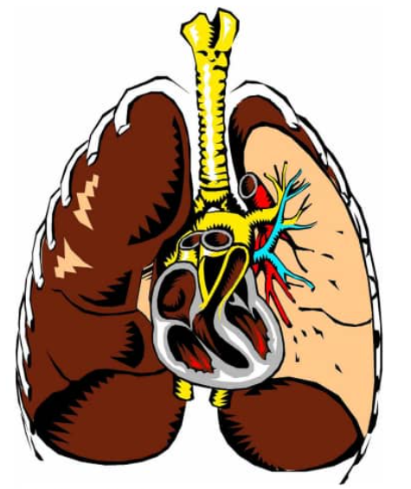
Source: Marques (2019)
Source: elaborated by the author (2024)

For tables, follow the pattern in Table 1. Regarding ABNT standards, use the following formatting for the table title and footer: Arial or Times New Roman font, size 10, single-spaced, centered alignment.

Table 1 - Distribution of the number and percentage of live births according to the mother's level of education
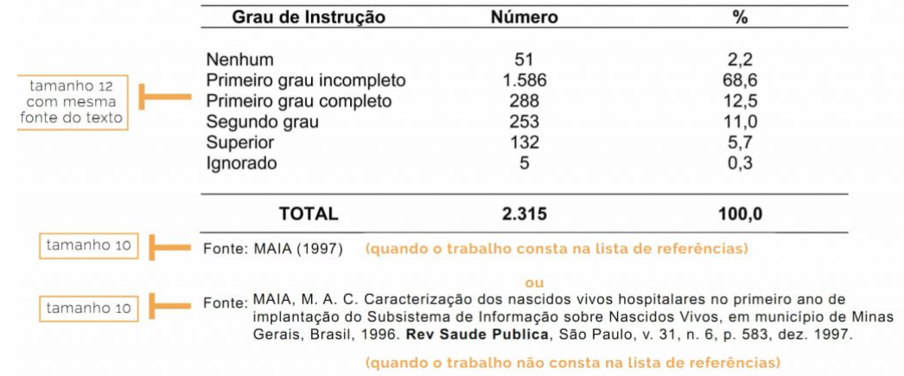

Any table that exceeds one page must have its identification and head repeated on the following page(s), with the indications “continued”, “continuation”, and “conclusion”.
Tables are mainly composed of words organized in rows and columns, and may or may not contain numbers for reference. They differ from tables in that they are more schematic and descriptive than statistical. Follow the rules in Table 1. Concerning ABNT standards, use the following formatting for the title and footer of the table: Arial or Times New Roman font; size 10; single-spaced; centered alignment.

Table 2 - Norms used to write a scientific article
Autor | Título | Data
ABNT | NBR 6023: Elaboração de Referências | 2002
ABNT | NBR 6028: Resumos | 2003
ABNT | NBR: Citação de Documento | 2002
IBGE | Normas de Apresentação Tabular. 3. Ed | 1993
Source: ABNT. NBR 6022 (2003)

3 MATERIAL AND METHODS (FONT SIZE 12)

The material and methods used in the research will be described here. The text should be justified in Times New Roman or Arial font, size 12, 1.5 spacing. Start paragraphs with a 1.25 cm indent. Use a space between the headings.

3.1 TITLE 2 (TITLE SHOULD BE WRITTEN IN CAPITAL LETTERS)

3.1.1 Title 3 (First Letter of Each Word in Capitals)

3.1.1.1 Title 4 (Only the first letter of the first word capitalized)

4 RESULTS AND DISCUSSION (FONT SIZE)

The results and discussion of the research will be described here. The text should be justified in Times New Roman or Arial font, size 12, 1.5 spacing. Start paragraphs with a 1.25 cm indent. Use a space between the headings.

4.1 TITLE (TITLE SHOULD BE WRITTEN IN CAPITAL LETTERS)

4.1.1 Title 3 (First Letter of Each Word in Capitals)

4.1.1.1 Title 4 (Only the first letter of the first word capitalized)

5 CONCLUSION (FONT SIZE 12)

The conclusions of the work will be described here. The text should be justified in Times New Roman or Arial font, size 12, 1.5 spacing. Start paragraphs with a 1.25 cm indent.

REFERENCES (FONT SIZE 12)

NBR 6023 regulates references in academic work (CBTs, theses, monographs). The References Manual (https://www.unaerp.br/infraestrutura/biblioteca/normas-e-abnt), available on the UNAERP library website, also provides examples of the correct formatting of references.
References should be aligned to the left, without indentation, in Times New Roman or Arial font, font size 12, single-spaced, alphabetized (NOT numbered), and with one blank line between each reference.
Several reference management software programs, such as Mendeley, Zotero, EndNote, and MORE, can help with bibliographic references.

